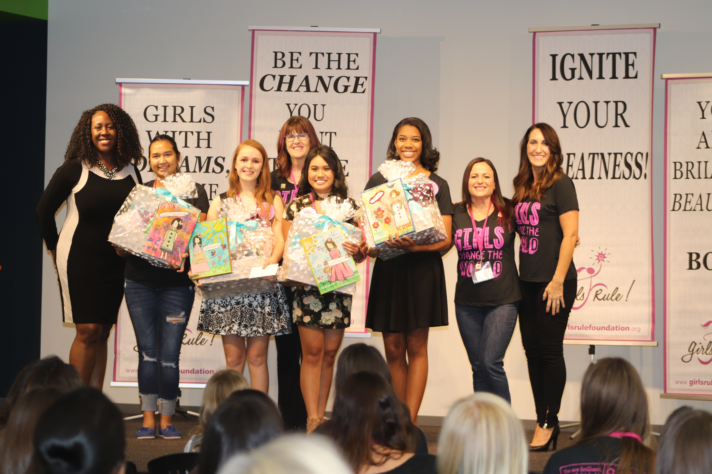

Contact:
Dena Patton

Girls Rule Foundation

Dena@girlsrulefoundation.org

(480) 282-4242/ (602)327-2619

Girls Rule Foundation Awards Fifth Annual
Brilliant, Beautiful and Bold Role Model Award & $500 to 4 Valley Teen Girls

FOR IMMEDIATE RELEASE
November 1, 2017
(PHOENIX, Ariz.) — The Girls Rule Foundation, a Phoenix non-profit organization that helps girls build confidence, leadership and bright futures, accepted 43 state-wide nominations from parents, teachers, coaches, leaders and peers statewide for the fifth annual Brilliant, Beautiful and Bold Role Model Award. The award was given to four exceptional Arizona girls ages 12-18 who make a difference in their community, in their family or in their school. Nominators were asked to write a short essay on how their nominee is a role model to others in brilliant, beautiful and bold ways. All nominees were invited to the Infusionsoft Conference Center on October 28 2017 during the 5th Annual Shine Brightly Summit to be acknowledged. The four winners were chosen by BBB Awards Chair, Tish Times and her committee and were awarded a custom art piece, a gift basket filled with $400 in prizes, along with $500 in cash to further their dream, a year of mentoring from professional success mentors and they will be the face of Girls Rule for 2018 as the title 2017 Brilliant, Beautiful and Bold Role Model Winners. More pictures and videos located at: http://girlsrulefoundation.org/awards/
The 4 winners pictured above with the Girls Rule CEO and Cofounder Dena Patton (far right) and Tish Times the BBB Award Chair (far left) with mentors: Lori Severson (back) and Laurie Sliva (second on right). Winners are:
- Yamile Martinez – 12th grade at Metro Tech High School
- Kylie Hunts-in-Winter - 9th grade at Arizona Connections Academy
- Stephanie Deleon - 12th grade at Buena High School; Sierra Vista
- Chloe Hiller – 9th grade at Arcadia High School

The Girls Rule Foundation believes in girls and their dreams. We are a Phoenix based 501c3 that offers 5 educational programs that help girls build leadership, self-confidence and bright futures. Please visit: www.girlsrulefoundation.org
– ### –

