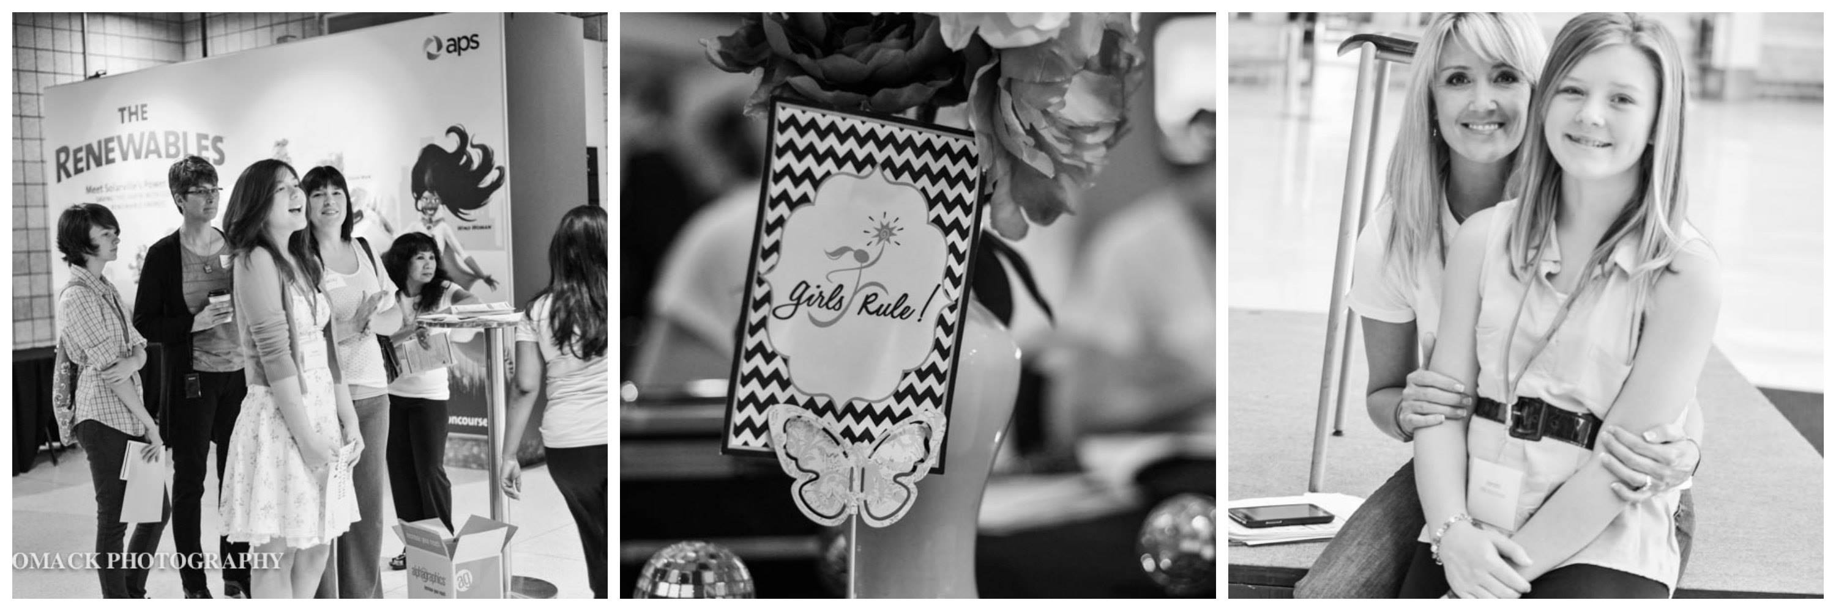

Media Contacts

Dena Patton

Girls Rule! Foundation

info@girlsrulefoundation.org

(480) 282-4242
Images for download here

Girls Rule Foundation Awards Third Annual Brilliant, Beautiful and Bold Role Model Award to 4 Valley Teen Girls

FOR IMMEDIATE RELEASE
November 25, 2015

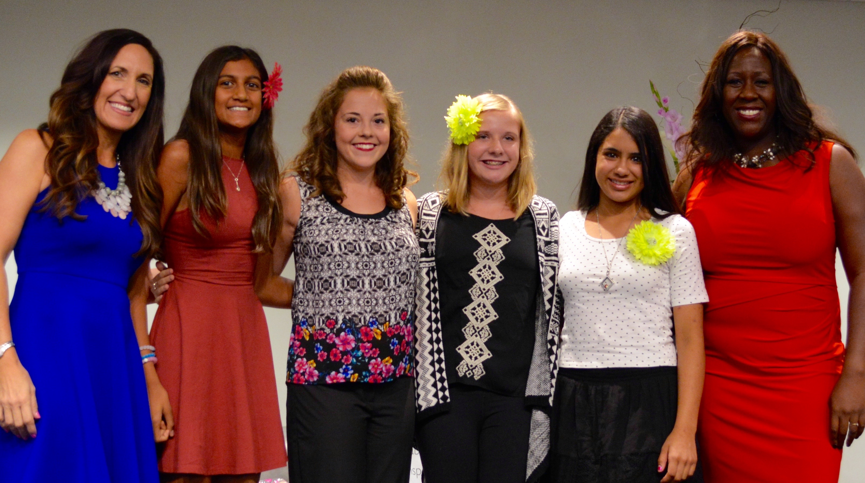
(PHOENIX, Ariz.) — The Girls Rule! Foundation, a Phoenix non-profit organization that helps girls build a bright future, accepted over 60 state-wide nominations from parents, teachers, coaches, leaders and peers statewide for the second annual Brilliant, Beautiful and Bold Role Model Award. The award was given to four exceptional Arizona girls ages 12-18 who make a difference in their community, in their family or in their school. Nominators were asked to write a short essay on how their nominee is a role model to others in brilliant, beautiful and bold ways. All nominees were invited to the Infusionsoft Conference Center on October 24 2015 during the 3rd Annual Shine Brightly Summit to be acknowledged. The four winners were chosen by BBB Awards Chair, Tish Times and her committee and were awarded a custom made gift basket filled with $400 in prizes, along with $500 in cash to further their dream, a year of mentoring and support, plus the title 2015 Brilliant, Beautiful and Bold Role Model. The 4 winners pictured above with the Girls Rule CEO and Cofounder Dena Patton (far left) and Tish Times the BBB Award Chair (far right): Annika Jackson from BASIS Scottsdale Jazzlyn Urenda from Bagdad High School Jessica Symmes from Desert Vista High School Rimona Rouf from Altadena Middle School.
About Girls Rule! Foundation:
The Girls Rule Foundation believes in girls and their dreams. We are a Phoenix based 501c3 that offers 4 educational programs that help girls build leadership, self-confidence and bright futures. Our goal is to help girls become our next generation of leaders, strong women, inventors, entrepreneurs, CEO’s and world changers. Our organization offers four programs, two of which are workshops that are offered locally at no cost for local schools, organizations, groups and teams to help girls ages 12-18. To learn about our organization, book programs or speeches, volunteer or donate, please visit: www.girlsrulefoundation.org
– ### –

